**Unit-1 Chapter-1 Lecture-1.2**

**Machine Learning Types**

**Introduction to Machine Learning**

With the help of Machine Learning, we can develop intelligent systems that are capable of taking decisions on an autonomous basis. These algorithms learn from the past instances of data through statistical analysis and pattern matching. Then, based on the learned data, it provides us with the predicted results.

Data is the core backbone of machine learning algorithms. With the help of the historical data, we are able to create more data by training these machine learning algorithms. For example, ***Generative Adversarial Networks***are an advanced concept of Machine Learning that learns from the historical images through which they are capable of generating more images. This is also applied to speech and text synthesis. Therefore, Machine Learning has opened up a vast potential for data science applications.

Machine Learning combines computer science, mathematics, and statistics. Statistics is essential for drawing inferences from the data. Mathematics is useful for developing ***machine learning models*** and finally, computer science is used for implementing algorithms.

However, simply building models is not enough. You must also optimize and tune the model appropriately so that it provides you with accurate results. Optimization techniques involve tuning the hyperparameters to reach an optimum result.

*Machine Learning is used in every domain*. It is being used to impart intelligence to static systems. With the knowledge acquired from the data, it is used to build intelligent products.

**Why Machine Learning?**

The world today is evolving and so are the needs and requirements of people. Furthermore, we are witnessing a fourth industrial revolution of data. In order to derive meaningful insights from this data and learn from the way in which people and the system interface with the data, we need computational algorithms that can churn the data and provide us with results that would benefit us in various ways. Machine Learning has revolutionized industries like medicine, healthcare, manufacturing, banking, and several other industries. Therefore, Machine Learning has become an essential part of the modern industry.

Data is expanding exponentially and in order to harness the power of this data, added by the massive increase in computation power, Machine Learning has added another dimension to the way we perceive information. Machine Learning is being utilized everywhere. The electronic devices you use, the applications that are part of your everyday life are powered by powerful machine learning algorithms.

Machine Learning example – Google is able to provide you with appropriate search results based on browsing habits. Similarly, Netflix is capable of recommending the films or shows that you would want to watch based on the machine learning algorithms that perform predictions based on your watch history.

Furthermore, machine learning has facilitated the automation of redundant tasks that have taken away the need for manual labor. All of this is possible due to the massive amount of data that you generate on a daily basis. Machine Learning facilitates several methodologies to make sense of this data and provide you with steadfast and accurate results.

**How does Machine Learning Work?**

With an exponential increase in data, there is a need for having a system that can handle this massive load of data. Machine Learning models like Deep Learning allow the vast majority of data to be handled with an accurate generation of predictions. Machine Learning has revolutionized the way we perceive information and the various insights we can gain out of it.

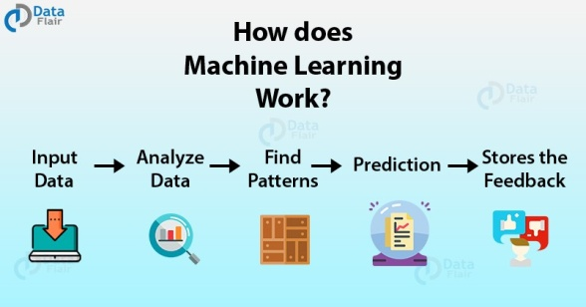

**Fig 2.1- Working of ML**

These machine learning algorithms use the patterns contained in the training data to perform classification and future predictions. Whenever any new input is introduced to the ML model, it applies its learned patterns over the new data to make future predictions. Based on the final accuracy, one can optimize their models using various standardized approaches. In this way, the Machine Learning model learns to adapt to new examples and produce better results.

**Types of Machine Learning**

Machine Learning Algorithms can be classified into 3 types as follows –

·        **Supervised Learning**

**·        Unsupervised Learning**

**·        Reinforcement Learning**

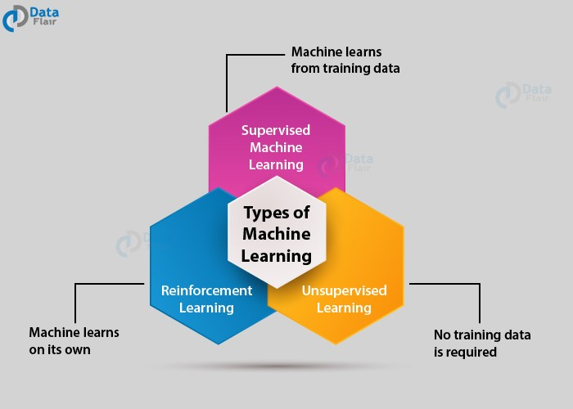

**Fig 2.2- Types of ML**

**Supervised Learning**

Supervised learning as the name suggests getting supervised by someone. It is a learning in which the machine uses data that is already tagged with the correct answer. After that, the machine is provided with a new set of data.

With the help of supervised learning, the algorithm analyzes the training data (set of training examples) and produces a correct outcome from labeled data.

Here the machine has already learned the things from previous data. So, now is the time it uses the learning wisely.

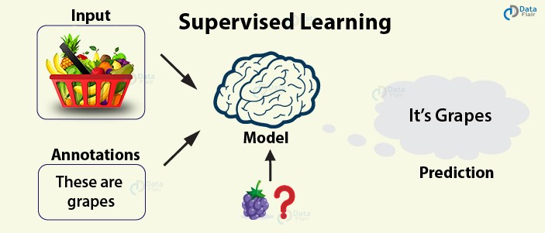

**Fig 2.3- Supervised Learning**

For example – if we take a fruit basket, the machine will first classify the fruit with its shape and color and would confirm the fruit name. If one searches for grapes, then machine learning from its training data (basket containing fruits) will use the prior knowledge.

It will then apply the knowledge to test data and will then provide you with the results.

In supervised learning, we start with a dataset that has training examples, each example has an associated label which identifies it.

**2. Unsupervised Learning**

In unsupervised learning, the training of the machine is done using the information which is neither classified nor labeled. The machine learning algorithm acts on information without guidance. It groups unsorted information according to similarities, patterns, and differences without any prior training or supervision.

Since there is no training given to the machine, the machine itself finds the hidden structure in unlabeled data and interprets it.

So, suppose if the machine is provided with the image of a pen and pencil and its information is not available then it can be categorized according to the similarities, patterns, and differences.

It is basically differentiated on the basis of pre-defined notions. The machine can estimate what kind of groups it can form to differentiate.

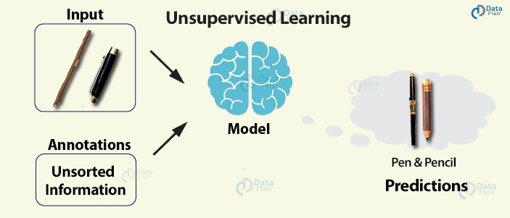

**Fig 2.4- Unsupervised Learning**

For example – a wooden stick with a cap can be a pen and with no cap a pencil. With no learning and no training, the machine tries to interpret itself.

**3. Reinforcement Learning**

Reinforcement learning is a very interesting kind of learning. There’s no answer key which can tell what’s right. But, the reinforcement learning agent still decides how to act to perform its task. This machine learning technique is all about taking actions that are suitable and maximize the reward in a particular situation. It is when the learner receives rewards and punishments for their actions.

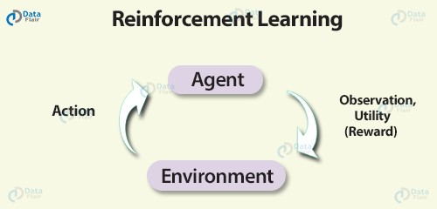

**Fig 2.5- Reinforcement Learning**

For example – In a given scenario, the reward could be utility and the agent could be told to receive as much utility as possible in order to “win”.

**Basically, the agent decides what to do to perform the given task. Now, since the training dataset is missing, it is bound to learn from its experience.**

**Machine Learning Algorithms**

Let us see some most common machine learning approaches:

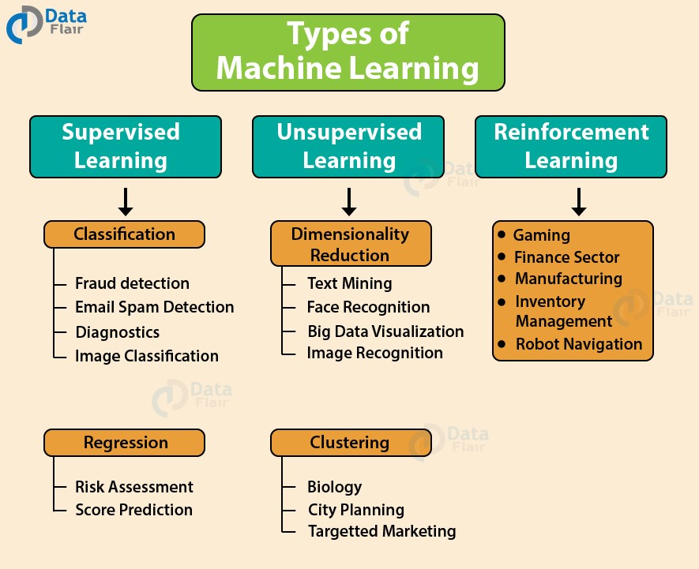

**Fig 2.6- ML Algorithms**

**Book Reading and Video Material**

* Understanding Machine Learning: From Theory to Algorithms by Shai Shalev-Shwartz and Shai Ben-David-Cambridge University Press 2014 [Download](https://www.cse.huji.ac.il/~shais/UnderstandingMachineLearning/understanding-machine-learning-theory-algorithms.pdf) Buy at Amazon
* Introduction to Machine Learning – the Wikipedia guide [Download](http://datascienceassn.org/sites/default/files/Introduction%20to%20Machine%20Learning.pdf)
* [Web link (data-flair)](https://data-flair.training/blogs/types-of-machine-learning-algorithms/)
* [Online Reading Material (Research gate)](https://www.researchgate.net/publication/221907660_Types_of_Machine_Learning_Algorithms)
* [NPTEL video](https://youtu.be/fC7V8QsPBec)